Final project pics

* Nmap search results

* Wp scan (step 3)

* Ssh as Michael

* Flag 2



* Flag 3

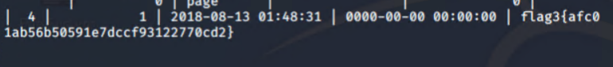

* Flag 4

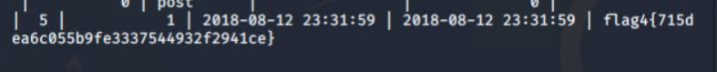

* Flag 1





* Mysql database (Step 5)
* Michael and steven hashes

* Logged in as Steven

* Crack hashes with John ( Step 7)

